Creating User Types
In EMIS all user types are based on 5 default user type profiles:

- Administration
- Doctor
- Nurse
- Other
- Principal

As “Administration” does not allow the user to be marked as a consulter, the user type of “Other” is widely used as a catch all. By creating additional named user types with the default profile of “other” the practice can benefit from enhanced user-based analysis without affecting the user’s current functionality.

Add a New User Type
- From the Main Module Page select UM - User Manager
- From the V - View Menu select User Types
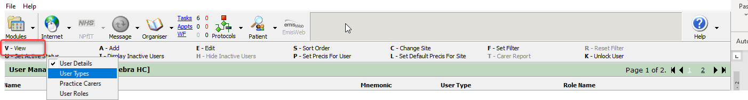
- Click Add and complete the dialog box as appropriate
- Choose “Other” in the Details Required drop down

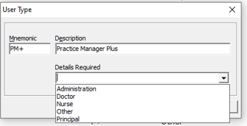
- Click OK

The User type will now appear in the user type list and can be selected when creating or amending an existing user

Recommended User Types to add
Mnemonic | Description | Detail Required
PM+ | Practice Manager + | Other
Phlb | Phlebotomist | Other

