This guideline will help you record patient encounters (Consultation Types) in EMIS in a consistent way. Recording consistently will help understand and evidence the considerable clinical workload in General Practice, including indirect patient care (i.e. dealing with results etc). Note: In EMIS, Consultation Type is referred to as “Place of Procedure” or “Location Type”. Your eHealth Facilitators will be able to assist with any guidance required on these processes.

Correct “Consultation Type” for the correct Clinician  Always ensure you are logged in to EMIS as yourself so that when the Consultation Header screen is displayed in Consultation Mode it will show you as the consulter and your surgery as the default “Place of Procedure” (Consultation Type).  - In the Consultation Header (shown below) check the time box to ensure chronological order in Consultation History.  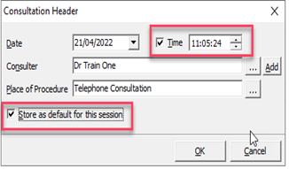  - If the consulter box is empty, please notify your Practice Manager.  - If the Place of Procedure (Consultation Type) is not correct for the consultation session CLICK the ellipsis button to choose an alternative (as shown in the “tele” example below).  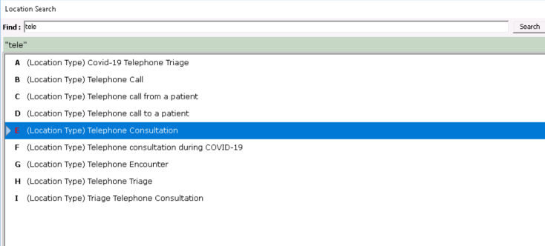  - Tick “Store as default for this session” so that you don’t have to change it every time. However, this can be changed on an individual consultation basis if required by clicking the Drop-down arrow in the Consultation Header and selecting the appropriate Place of Procedure (see below).  Changing your Consultation Type per Consultation  Each time you change your “Consultation Type” from your default, e.g. from “Telephone Consultation” to “Face to Face”, you should select the appropriate Consultation Type from the drop-down from the Consultation Mode Header Bar.  - Click the drop-down arrow on the Consultation Mode Header Bar and click the appropriate Consultation Type.  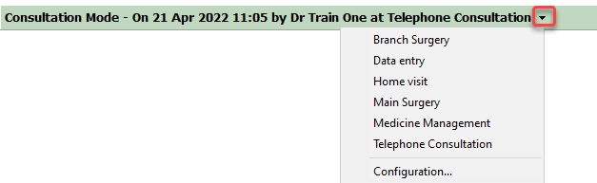  General Recording Guidance  Use the consultation type that best approximates the whole consultation - don’t open multiple consultation types in a single episode. For example, Video Consultation only if converted from a phone call. NB: A separate consultation type should be recorded for each discrete consultation. For example, an initial triage telephone consultation followed by a face-to-face consultation.  DNA / Failed encounters - For patients that missed an appointment or could not be contacted, keep the encounter type that has been missed and add the appropriate DNA/failed encounter code to the clinical record. Examples include:  Encounter Type Code Description  F2F 9N41. DNA – reason given  9N42. DNA – no reason  TC 9N4.. Failed encounter  9N4C. No answer when rang back  9N4F. Message left on answer machine  Incorrect Consultation Type If you choose an incorrect type of consultation: Right-click and edit the relevant consultation in the “medical record – consultation history”. Change the encounter type. | Recommended Consultation Types (Locations)  Below is the main “Place of Procedures” (Consultation Type) list that is recommended for use:  Main Surgery (or name) Branch Surgery (or name)  Telephone Consultation Home Visit  eConsultation Video Consultation  Medicine Management Third Party Consultation  Administration Triage  If additional Consultation Types are required these can be added and agreed within the practice to ensure consistency.  Consultation Type Definitions  Below are examples of encounter types and when they should be utilised:  Main Surgery/Branch Surgery - Face to Face (F2F) Surgery Consultation, F2F Emergency Consultation.  Telephone Consultation - Telephone call to/from a patient, and Telephone Triage.  Home Visit - Home Visit, Nursing Home Visit and Residential Home Visit.  eConsultation - email, electronic triage/information, SMS, DACS. Processing of econsultations by admin staff should be entered as administration encounter types.  Video Consultation - e.g. Near Me.  Medicine Management - indirect contact relating to prescribing. This includes issuing acute medication, generating and re-authorising repeat medications, polypharmacy reviews, medicines reconciliation etc. It does not include prescriptions generated by direct contact e.g. during a consultation - this would be a direct encounter.  Third Party - consultation about a patient, but not with the patient. These are mostly telephone encounters, but can be F2F or other encounter types. These should all be recorded as 3rd party consultations.  Administration - Letter from outpatients, mail to/from patient, discharge details, out of hours reports, dealing with results, preparing reports etc.  Triage - an encounter to direct the patient to the most appropriate member of the general practice team or other service.

