Basic steps for practices to follow for the measurement component of the Frailty DES
Supporting this step-by-step guide is a demo of the dashboard at this link
- Download the GP in-hours activity dashboard.
- Click on the continuity tab at the top of the screen
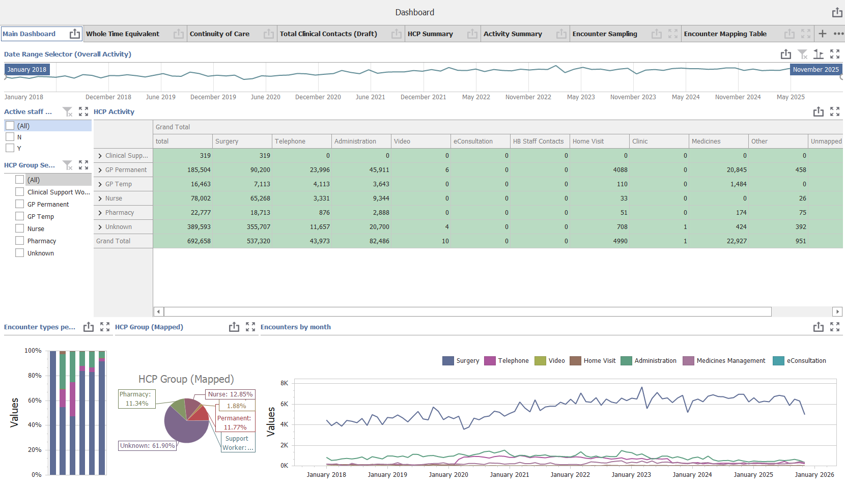
- Click on the Frailty filter in the centre of the screen, shown in the screenshot below. This brings up a list of all patients coded with frailty who have attended the practice 3 or more times over the last year.
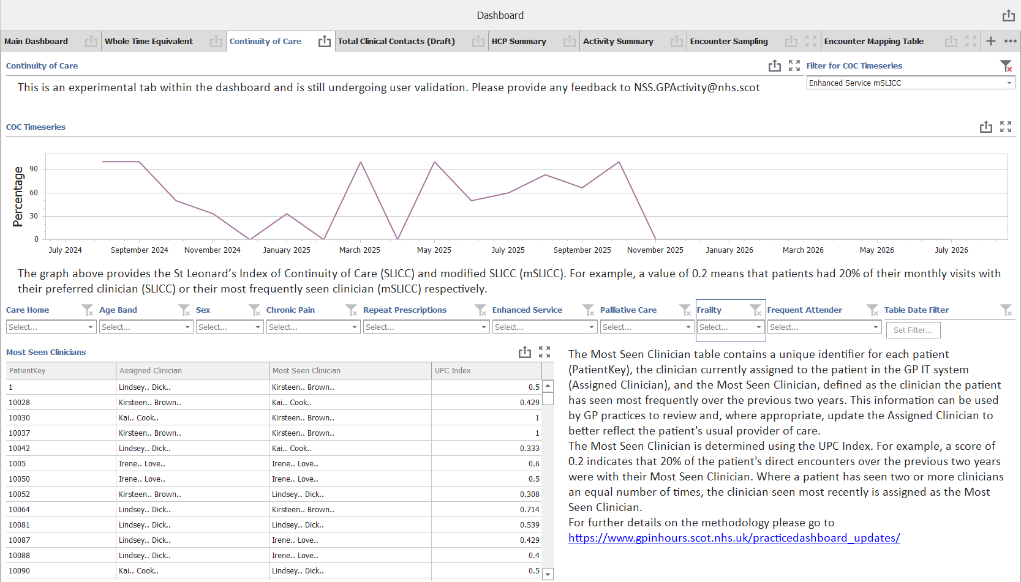
- From this list, choose 10 patients for the Frailty DES.
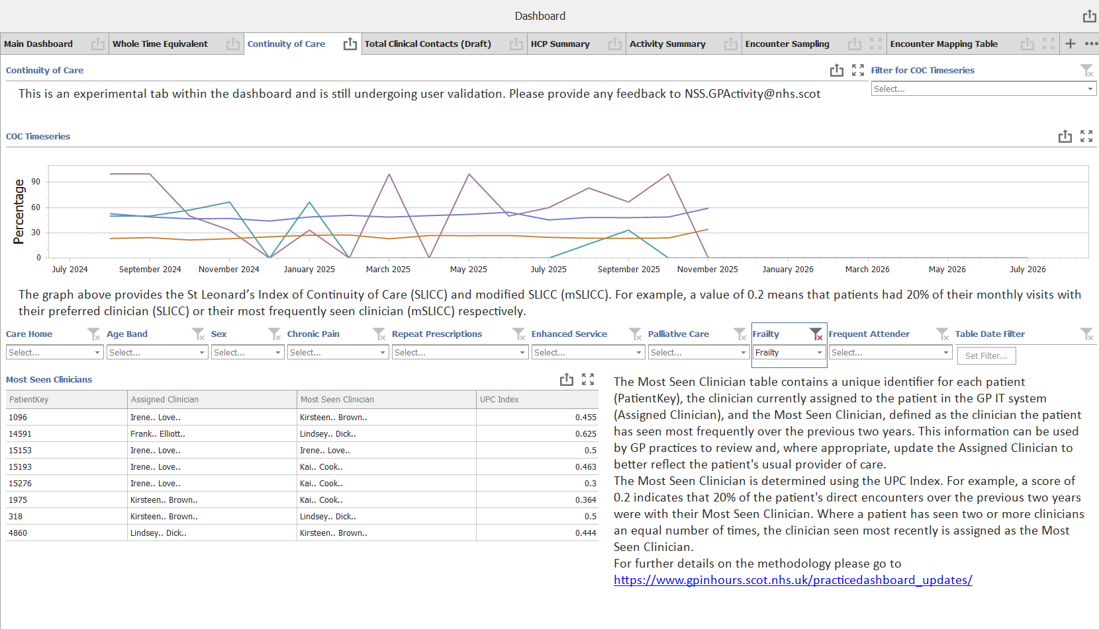
- Add the ES Read code in the GPIT system for this selected cohort of patients: 8O23. Provision of continuing care
- Agree a ‘named GP’ for these 10 patients and enter that in the GPIT system (in ‘usual GP’ box in Vision, or equivalent in EMIS)
- Add an alert to the patient record to say that they have a named GP as part of the Frailty DES. NB: any changes made in the GPIT system will take up to 24 hours to update in the continuity dashboard.
- Run the continuity score by clicking on filter in the top right of the dashboard screen (select the option: ‘enhanced service mSLICC’ in the dropdown list)
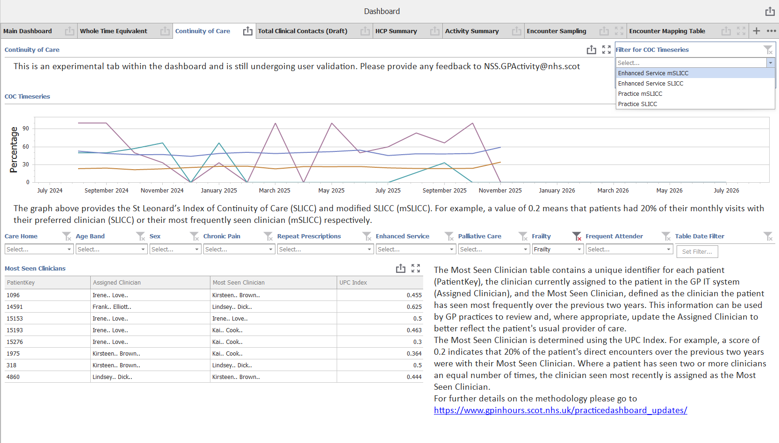
- Click on ‘export’ (centre right of screen) to export the search data into Excel to save
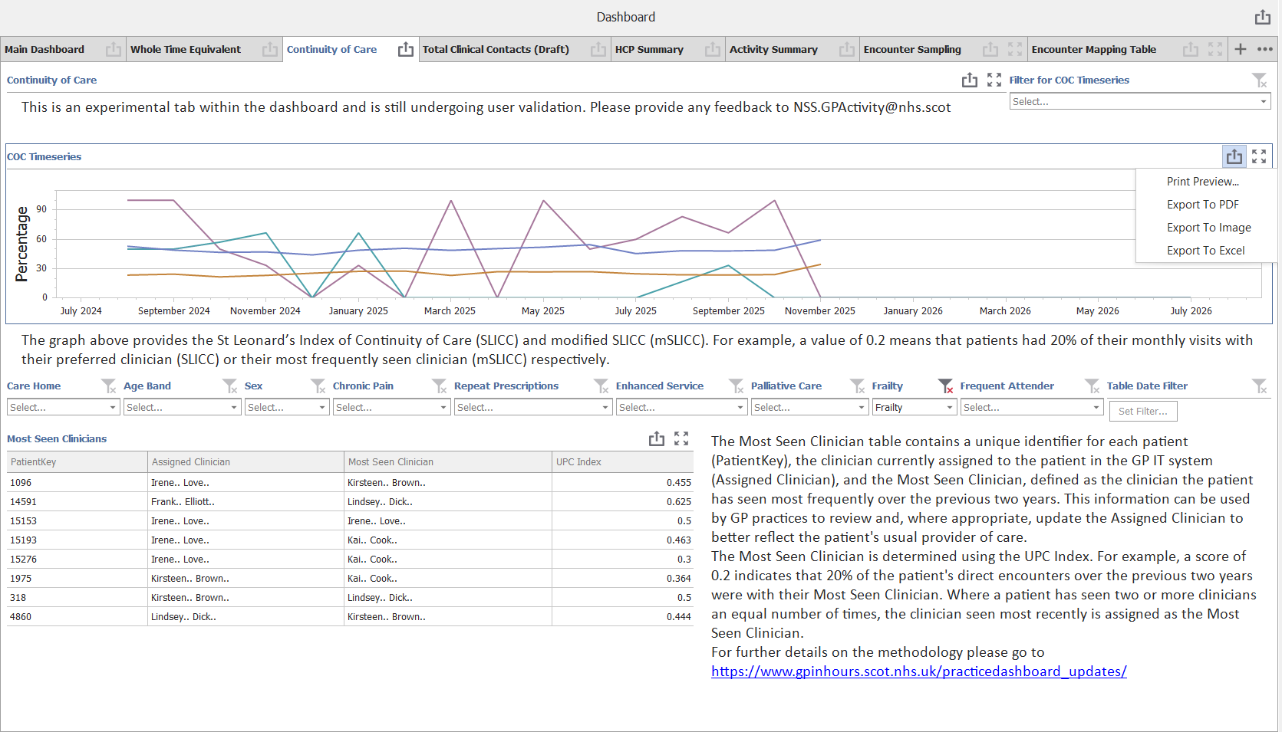

- Complete steps 7 and 8 at the beginning of participation in the Frailty DES and repeat 6 months later (or before 31 March 2027).

Notes:
For practices that have recently migrated from EMIS to Vision, it is recognised that this has resulted in less reliable ‘encounter’ data. This impacts on the validity of the scores – but this doesn’t matter for the purposes of the DES as the requirement is only to show that a search has been successfully run using the software.

