This guideline will help you record patient encounters (Consultation Types) in Vision in a consistent way. Recording consistently will help understand and evidence the considerable clinical workload in General Practice, including indirect patient care (i.e. dealing with results etc). Your eHealth Facilitators will be able to assist with guidance on the below.

Correct “Consultation Type” for the correct Clinician  Always ensure you are logged in to Vision as yourself so that when you open up a consultation it is already set to the type of consultation that you use most often.  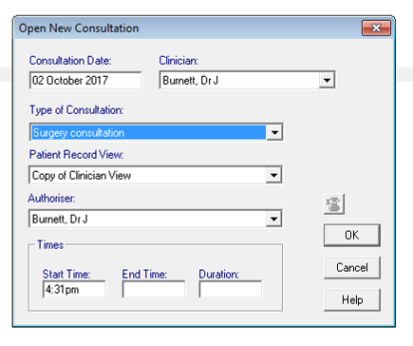  - The screen below should pop up when you open a new consultation. If it doesn’t you can alter defaults via Consultation Manager Setup (Consultation – Options – Setup).  - Check it is set for the correct type of consultation and make sure that the clinician and authoriser are you.  - If you need to alter the type of consultation you can click on the menu and scroll up and down to select the correct one.  - You can also select the type of consultation by using the keyboard shortcuts shown in the table below.  Clinical Scenario Keyboard Shortcut  Surgery Consultation / Default s  Telephone Consultation tt  Triage tttt  Patient Home Visit h  Visit to local Nursing Home nnnnn  Video Consultation (‘Near Me’ etc) v  eConsult/email e  Third Party Encounter (phone/face to face) ttt  Docman/Reports/Letters aa  Prescribing/Medicines work mmm  Consultation Type Definitions  Below are examples of encounter types and when they should be utilised:  Surgery Consultation - Face to Face (F2F) Surgery Consultation, F2F Emergency Consultation.  Telephone Consultation - Telephone call to/from a patient.  Triage - encounter to direct the patient to the most appropriate member of the general practice team or other service.  Home Visit - Home Visit, Nursing Home Visit and Residential Home Visit.  Video Consultation - e.g. Near Me.  eConsultation - email, electronic triage/information, SMS, DACS. Processing of econsultations by admin staff should be entered as administration encounter types.  Administration - Letter from outpatients, mail to/from patient, discharge details, out of hours reports, dealing with results, preparing reports etc. | Third Party - consultation about a patient, but not with the patient. These are mostly telephone encounters, but can be F2F or other encounter types. These should all be recorded as 3rd party consultations.  Medicine Management - indirect contact relating to prescribing. This includes issuing acute medication, generating and re-authorising repeat medications, polypharmacy reviews, medicines reconciliation etc. It does not include prescriptions generated as a result of direct contact e.g. during a consultation- this would be a direct encounter.  General Recording Guidance  - Please try to adhere to the “Consultation Types” set out in the adjacent definitions. Don’t use “Other” and avoid “Clinic” if possible as these are ambiguous. Use appropriate type e.g. surgery consultation.  - Use the consultation type that best approximates the whole consultation - don’t open multiple consultation types in a single episode. For example, Video Consultation only if converted from a phone call. NB: A separate consultation type should be recorded for each discrete consultation. For example, an initial triage telephone consultation followed by a face-to-face consultation.  - Try and open and close a consultation in real time if possible. This ensures that an accurate duration of consultation time is recorded in Vision.  DNA / Failed encounters - For patients that missed an appointment or could not be contacted, keep the encounter type that has been missed and add the appropriate DNA/failed encounter code to the clinical record. Examples include:  Encounter Type Code Description  F2F 9N41. DNA – reason given  9N42. DNA – no reason  TC 9N4.. Failed encounter  9N4C. No answer when rang back  9N4F. Message left on answer machine  Incorrect Consultation Type - If you choose an incorrect type of consultation in error, double click on the consultation type displayed at the bottom right of the consultation manager as shown below and change it.  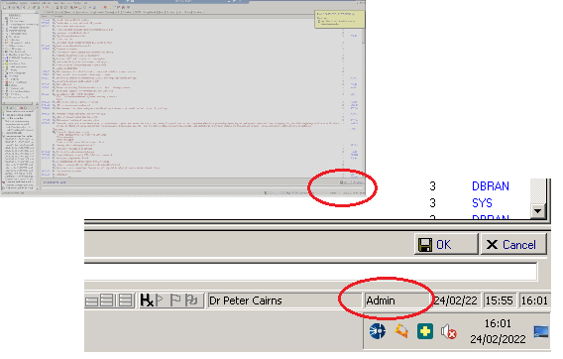  VISION Consultation recording guidance (v1.7)

